Pokhara University

Level: Bachelor | Semester – Spring | Year : 2009
Programme: BE |  | Full Marks : 100
 |  | Pass Mark : 45
Course: Electromagnetic Fields and Waves |  | Time : 3 hrs

Candidates are required to give their answers in their own words as far as practicable.
The figures in the margin indicate full marks.

Attempt all the questions.

1. | - Derive Electric Field Intensity. Derive the expression for E due to a line charge of finite length. Compare the result with that of sheet charge.  - State Gauss's law. Use it to find the electric field due to a spherical conductor of radius 'a' having charge Q at a point r distance from its centre | 8  7
2. | - Given the potential 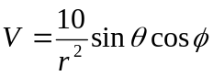, find the electric flux density D at (2, π/2, 0) and calculate the work done in moving a 20μC charge from point A(1, 30°, 120°) to B(4, 90°, 60°).  - Define polarization in dielectrics. Prove that 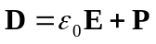where the variables have their usual meanings. | 8  7
3. | - State principle of conservation of charge. Considering the bounded close surface for a continuity of current derive the point form of continuity equation.  - A current of 2A is flowing in the direction in the filament extending along the z-axis. Find 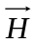at (1,0,0), if the filament goes between (i) 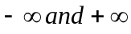 (ii) -10 and +10. | 8  7
4. | - What do you mean by vector magnetic potential? Why is it necessary?  - The magnetic circuit of Fig. 2 has current 10A in the coil of N = 2000 turns. Assume that all branches have the same cross section of 2cm² and that the material of the core is iron with μ_{r} = 1500. Calculate the magnetic flux passing through the air gap.  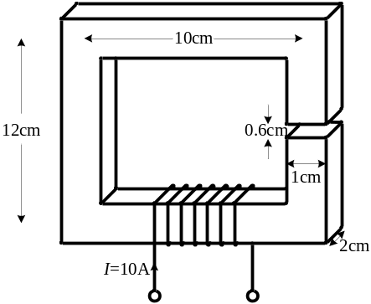  - State Ampere’s circuital law. What is the conflict between Ampere’s circuital law & equation of continuity? Solve the conflict. | 5  5  5
5. | - Explain uniform plane wave mathematically. Discuss the nature and characteristics of wave motion in perfect dielectrics.  - Starting from Maxwell's equations and implementing vector in identities show the relation for Poynting vector 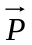in terms of 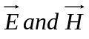. | 8  7
6. | - A line with negligible losses having characteristics impedance of 200 Ohms is terminated in a load impedance of (100 + j180) Ohm. Find using Smith chart  - Standing wave ratio  - Reflection coefficient  - Position of maximum voltage from load.  - Derive an expression for the propagation constant γ and characteristic impedance Z₀ of a transmission line with resistance per unit length, capacitance per unit length, inductance per unit length and reluctance per unit length as R, C, L and G respectively. | 8  7
7. | Write short notes on (Any Two):  - Wave guides  - Skin Effect  - Ampere's circuital Law | 2×5

